Matlab:

clear all**;**

% Audio Portion

fid **=** fopen**(**'lpf_260_400_44100_80db.bin'**,** 'rb'**);**

ndim **=** fread**(**fid**,** 1**,** 'int'**);**

nchan **=** fread**(**fid**,** 1**,** 'int'**);**

dim0 **=** fread**(**fid**,** 1**,** 'int'**);**

dim1 **=** fread**(**fid**,** 1**,** 'int'**);**

dim2 **=** fread**(**fid**,** 1**,** 'int'**);**

h **=** fread**(**fid**,** inf**,** 'float'**);**

fclose**(**fid**);**

% Calculate H(w)

N **=** 2**^**14**;** % FFT size

f **=** **(**0**:**N**-**1**)\***dim1**/**N**;** % Make frequency vector for plotting

H **=** abs**(**fft**(**h**,**N**)).^**2**;** % Compute the magnitude reponse

%Plot the filter response

figure**(**1**);**

subplot**(**2**,** 2**,** 1**);**

stem**(**h**);**

title**(**'h[n]'**);**

set**(**gca**,** 'FontSize'**,** 16**);**

grid on**;**

subplot**(**2**,** 2**,** 2**);**

semilogx**(**f**,** 10**\***log10**(**H**));**

xlim**([**0 dim1**/**2**]);**

ylim**([-**100 10**]);**

title**(**'H(w)'**);**

xlabel**(**'Frequncy (Hz)'**,** 'FontSize'**,** 18**);**

ylabel**(**'Gain (db)'**,** 'FontSize'**,** 18**);**

set**(**gca**,** 'FontSize'**,** 16**);**

grid on**;**

% Parse the audio

**[**x**,** fs**]** **=** audio2bin**(**'fireflyintro.wav'**);**

%sound(x, fs);

% Apply the filter

x2 **=** conv**(**x**,** h**);**

**[**x3**,** fs3**]** **=** bin2audio**(**'fireflyintro_pfp.bin'**);**

%sound(x2, fs);

%sound(x3, fs3);

% Plot the spectrograms

nfft **=** 2**^**8**;**

overlap **=** round**(**0.8**\***nfft**);**

window **=** hamming**(**nfft**);**

subplot**(**2**,** 2**,** 3**);**

spectrogram**(**x**,** window**,** overlap**,** nfft**,** fs**);**

title**(**'Before Filter'**);**

set**(**gca**,** 'FontSize'**,** 16**);**

grid on**;**

subplot**(**2**,** 2**,** 4**);**

spectrogram**(**x3**,** window**,** overlap**,** nfft**,** fs**);**

title**(**'After Filter'**);**

set**(**gca**,** 'FontSize'**,** 16**);**

grid on**;**

clear all**;**

% Video Portion

**[**x1**]** **=** image2bin**(**'cameraman.tif'**);**

**[**x2**]** **=** image2bin**(**'John Fiddle.jpg'**);**

main.cpp

#include <iostream>

#include "../Shared/dspf.hpp"

const std::string filter = "lpf_260_400_44100_80db.bin";

const std::string firefly = "output\\fireflyintro.bin";

const std::string firepfp = "output\\fireflyintro_pfp.bin";

const std::string firertp = "output\\fireflyintro_rtp.bin";

const std::string img1 = "output\\cameraman.bin";

const std::string img1_out = "output\\cameraman_edge.bin";

const std::string img2 = "output\\John Fiddle.bin";

const std::string img2_out = "output\\John Fiddle.bin";

void audio_full() {

DSPFile

fin(firefly),

lpf(filter),

fout(firepfp, DSP::Mode::Write);

if (!fin.ready() || !lpf.ready() || !fout.ready()) {

return;

}

dsig h = lpf.read_all();

dsig x = fin.read_all();

int h_size = h.size(),

d_size = x.size(),

o_size = d_size + (h_size - 1);

dsig out(o_size, 0);

fout.Header = fin.Header;

fout.Header.dim0 = o_size;

// Apparently array access on vectors is ridiculously slow (visual studio compiler)

float

* pout = out.data(),

* ph = h.data(),

* px = x.data();

for (int j = 0; j < h_size; ++j) {

if (ph[j] == 0) { continue; }

for (int i = 0; i < o_size; ++i) {

if (!(i - j < d_size)) { break; }

if (!(i - j < 0)) {

pout[i] += ph[j] * px[i - j];

}

}

}

fout.write_h();

fout.write_d(out.data(), o_size);

}

void audio_realtime() {

DSPFile

fin(firefly),

lpf(filter),

fout(firertp, DSP::Mode::Write);

dsig h = lpf.read_all();

int buf = h.size();

dsig x(buf, 0);

// Fix the header

fout.Header = fin.Header;

//fout.Header.dim0; // The circular buffer chops the tails

fout.write_h();

// Apparently array access on vectors is ridiculously slow (visual studio compiler)

float

* ph = h.data(),

* px = x.data();

int k, i = buf - 1;

px[i] = fin.read_1();

while (fin.ready()) {

float y = 0;

for (k = 0; k < buf; ++k) {

y += ph[k] * px[(k + i) % buf];

}

i = (i + buf - 1) % buf;

fout.write_d(y);

px[i] = fin.read_1();

}

}

float* conv2(const float* x, int mx, int nx, const float* h, int mh, int nh) {

}

void image_grayscale() {

DSPFile

fin(img1),

fout(img1_out, DSP::Mode::Write);

dsig x = fin.read_all();

}

void image_color() {

}

int main() {

//audio_full();

//audio_realtime();

image_grayscale();

system("pause");

return 0;

}

dspf.hpp:

#pragma once

#include <string>

#include <memory>

#include <vector>

#include <fstream>

namespace DSP {

static enum Mode { Read = 1, Write = 2, RealTime = 4 };

static enum Type { Audio = 1, Image = 2, Video = 3 };

static struct color { float r, g, b; };

static float gray(color c) {

return (0.2989f * c.r) + (0.5870f * c.g) + (0.1140f * c.b);

};

}

typedef std::vector<float> dsig;

typedef std::vector<DSP::color> dpix;

typedef std::vector<std::vector<float>> dsig_block;

typedef std::vector<std::vector<DSP::color>> dpix_block;

struct dsh { int ndim, nchan, dim0, dim1, dim2; };

class DSPFile {

private:

std::string file;

std::fstream fid;

DSP::Mode fmode;

bool valid = true;

void close() { fid.close(); valid = false; };

public:

dsh Header;

~DSPFile() { close(); }

bool ready() { return valid; }

DSPFile(std::string, DSP::Mode fm = DSP::Mode::Read);

float read_1();

dsig read_all();

void write_h();

void write_d(float*, int);

void write_d(float);

};

dspf.cpp:

#include "dspf.hpp"

#include <iostream>

using namespace DSP;

DSPFile::DSPFile(std::string f, Mode fm) {

file = f;

fmode = fm;

int mode = std::ios::binary;

// TODO: Consider revising to handle read/write cases

switch (fmode) {

case Mode::Read:

mode |= std::ios::in;

break;

case Mode::Write:

mode |= std::ios::out | std::ios::trunc;

break;

};

fid = std::fstream(file, mode);

if (!fid) {

std::cout << "Error fetching: " << file << std::endl;

close();

return;

}

if (fmode & Mode::Read) {

fid.read(reinterpret_cast<char*>(&Header), sizeof(dsh));

}

}

float DSPFile::read_1() {

float data;

fid.read(reinterpret_cast<char*>(&data), sizeof(float));

valid &= !fid.eof();

return data;

}

dsig DSPFile::read_all() {

dsig data;

float temp;

while (true) {

fid.read(reinterpret_cast<char*>(&temp), sizeof(float));

if (fid.eof()) { break; }

data.push_back(temp);

}

close();

return data;

}

void DSPFile::write_h() {

fid.write(reinterpret_cast<char*>(&Header), sizeof(dsh));

}

void DSPFile::write_d(float* data, int n) {

fid.write(reinterpret_cast<char*>(data), sizeof(float) * n);

}

void DSPFile::write_d(float data) {

fid.write(reinterpret_cast<char*>(&data), sizeof(float));

}

Output for Audio Portion

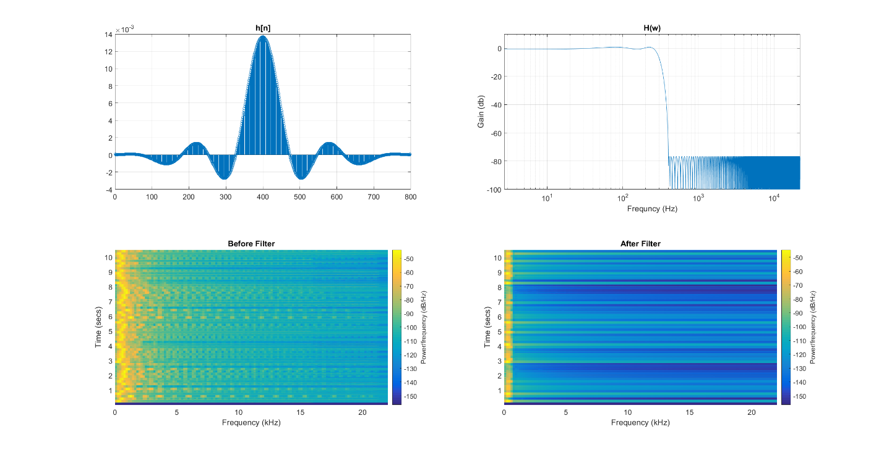

What is the benefit of zero-padding?

I’m still really confused on this point. It seems to me the only benefit would be to do in-place operations rather than allocating twice the memory. Perhaps some speed benefits from not having to check boundary conditions (resulting in conditional branches in a loop) but in modern architectures this effect would be small. What’s more it changes the operation of convolution from addition to subtraction (really, how?!)

What is the benefit of using a circular buffer?

Easy. Shifting is expensive. Using a circular buffer and pointer arithmetic is much faster!